“Adaptive Reuse of CaixaForum by Herzog and De Meuron”
Student Name
Student ID

Course Name
Professor’s Name
University name
Date

“Adaptive Reuse of CaixaForum by Herzog and De Meuron”

The “adaptable reuse” concept is slowing gaining momentum among modern interior designers for revitalising old buildings and structures and giving them a new life without maligning their historical significance. This technique finds novel approaches for utilising older structures while also emphasising on their sustainability and longevity (Aigwi, Duberia, and Nwadike, 2022). The "CaixaForum" complex lying in the central region of Madrid City is one such example of a historical structure that has been transformed through this technique. This transformation is led by well-known designers Herzog and De Meuron who assumed the responsibility of redeveloping a power station built in 1899 into a modern, state-of-the-art culture center (201 Caixaforum Madrid-2022).
This structure holds immense significance not only because of the way it has been designed, but also for the way it displays how its society has evolved over time, reflecting the city's cultural shifts over time. This essay is an attempt to explore the remarkable journey and transformation of CaixaForum's by unveiling the multifaceted stretches connecting its past as well as present stories. Therefore, the objective of the essay is to explore the significant implications of Herzog and De Meuron's adaptive reuse practices to illustrate how much significant it is in the larger context of Madrid's historic, cultural and architectural heritage. By doing so, this essay tries to highlight the significant impacts of adaptive reuse concept in the context of interior design.
Historical context and significance of CaixaForum:
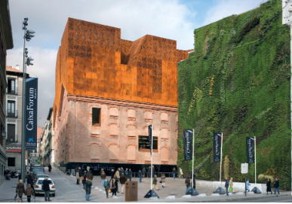
Figure 1: CaixaForum front view; Source: (201 Caixaforum Madrid, 2022)
The history of the CaixaForum finds an intricate connection with that of Madrid. Its construction started in the latter half of the 1800s as a power station to meet the growing electricity needs of the city (Hatherley,, 2018). Once completed, it has contributed immensely to support the erection and development of other infrastructure and industrial endeavours and was seen as a sign of progress during that period. Over the years, this structure witnessed changes along with the evolving social and political climate of Madrid, while bearing serene witness to its history.
The transformation of this structure, from an old power plant to an artistic landmark displays how meticulous Herzog and De Meuron are about preserving history (Plevoets, 2021). They proved to be extremely successful at saving the building's original features while finding inventive uses for them. This made the building an appealing combination of old and new. The designers worked hard to keep the building's industrial character and used its heavy structure parts to make a mix of old and new designs that appeared natural (Mao, 2018). They made sure that the structure's historic spirit was kept alive while lending it an entirely novel function by adding modern features like steel girders and open bricks between old ones.
CaixaForum matters for more than just its building; it's also strongly attached to Madrid's cultural and artistic life. Redeveloping the building in the middle of "Paseo del Prado," an area with a lot of art history, is the start of a culture rebirth (Gregorio Hurtado et al. 2019). The transformation into a modern art and culture hub shows that Madrid wants to respect its history while simultaneously gazing to the future, which will be built on art, learning, and community service. The fact that this site is in close proximity to famous museums like "The Prado" and "The Reina Sofía Museum" makes it even more culturally significant (Naqvi, 2023). Together, they build a "cultural corridor" that includes a wide range of art forms and past connections. This setting fits with Madrid's image as a lively cultural hub, offering both tourists and locals a carefully planned experience that mixes the old and the new, tradition and creativity.
Architectural aspects of CaixaForum:
Following the adaptive reuse approach led by Herzog and De Meuron's, CaixaForum has been redeveloped into a modern architectural structure with a unique mix of its past and present and serve useful for various purposes, like artwork, educational, or even social gatherings. The primary space for exhibits within the newly developed building was the turbine hall of the old structuring encompassing a power station (Taddonio and Aydeniz, 2020). Given that the structure is of massive size, it radiates a sense of "magnificence," making it a great place for artistic purposes. The builders skillfully turned the old power station structure into an even more flexible space that may be used for many arts and culture events while still keeping the structure's original size and look.
How visitors may feel or what they observe is also affected by the manner in which the new building is organised along with how easy it is to get around. The designers carefully planned out smooth paths that take people on an interesting walk. The design stimulates an immersive journey by meandering through its halls, transitional areas, as well as outdoor gardens (Milojković and Nikolić, 2012). This also ensures that there is an easy transition across exhibits and allows for plenty of ways for visitors to engage with cultural and artistic events. Such a planned layout and space creates an aura of wonder and discovery which makes people desirable to connect with the space in a meaningful way. The skilful choice of materials, construction methods, and architectural aspects has been the key to the success of adaptive reuse concept in the case of CaixaForum. The designers, Herzog and De Meuron, selected a wide range of materials that can better connect to the building's industralised history.
Some of the key elements used in this building such as weathered steel, glass materials, mortar etc. honour its history while also being open to recent upgrades (Mao, 2018). The designers skilfully balanced restoring the original features of the building, such as the brick facade or industrial elements, alongside incorporating modern touches, which creates an intersection between its past and the present that strengthens the architectural integrity.
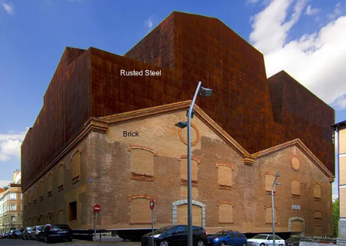
Figure 2: Exterior of CaixaForum; Source: (Mao, 2018)
Also, the creative use of such construction materials goes beyond its interior and into outdoor areas as well. The square-by-square form of the building's exterior is shown by the dark upper half of the building in Figure 2. The designers turned the area around the structure into a culture oasis by using both hardscape as well as lush vegetation to make outdoor areas that people want to be in. Also, the interior layout (shown in Figure 3) uses a lot of sharp angles and different geometric shapes that make the experience better by allowing people to engage, which improves the overall experience of visitors.
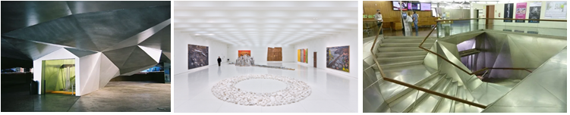
Figure 3: Interior design of CaixaForum; Source: (Mao, 2018)
Analysis of design interventions:
The design interventions introduced by Herzog and De Meuron in the case of CaixaForum follows an expansive conceptual framework spanning beyond simple architectural adaptations. It presents a story connecting with the surrounding while also prioritising sustainability. The approach they used integrates the essential elements from the post of the building with a fresh vision for its future that can be seen in both the architecture and the surroundings.
Creating an aesthetically pleasing link between the new building with its surroundings forms the heart of their renovation (Hreciuc, 2020). The designers purposely blended both its interior and exterior areas, making the building look like it was always a part of the city. Besides, the design of the building also supports engagement to its surroundings, including the public areas and cultural centers and museums nearby. Such smooth mixing creates a unified metropolitan experience, strengthening the cultural route along the "Paseo del Prado" and making it easy for visitors to go from one cultural location to another.
Herzog and De Meuron's adaptable reuse approach is also based on the idea of sustainability. In addition to maintaining the building's historical significance, the two designers made it their priority to use environmentally friendly building methods. The interventions introduced focuses on energy efficiency through passive design techniques to make the most from natural lighting and air flow (Schröpfer, 2012). Besides, the application of eco-friendly systems and materials in reconstructing this building while also lowering its impact on the surroundings which is in line with modern ideas of responsible design.
The CaixaForum's adaptable reuse extends beyond its architectural beauty; it also raises awareness and educates people about the environment. The transformation of this structure into a cultural hub shows how adaptive reuse can be a viable sustainable practice to encourage people to engage with how to improve existing structures rather than building new ones. The narrative pushes for an overhaul shift within the architect and building community, calling for a more deliberate approach which can account for the way designing interventions affect the environment. Herzog and De Meuron's design interventions adopt a more complete view that goes beyond the limits of architecture. It transforms the function of the building as a forum for people to engage, exchange ideas and discuss their cultural, social, and environmental issues.
Broader context and influence of Herzog and De Meuron on adaptive reuse trend:
CaixaForum is not the only creation of Herzog and De Meuron. They are credited to have designed an extensive collection of projects with distinctive design, ideas and in-depth comprehension of associating projects of such size and scale with sustainability. Some of the most notable work includes famous buildings around the world, showcasing distinct architectural designs and expression.
The way CaixaForum has influenced the surrounding areas in Madrid is a clear indication of the increasing significance of such adaptive reuse concepts. In addition of being an exemplary work of architecture, this building also serves as a driving force behind the cultutal and artistic revitalisation of 'Paseo del Prado', making the surrounding regions a lively cultural neighbourhood again (Moshaver, 2011). Its vicinity with several other renowned museums like "The Prado Museum" and "The Reina Sofía Museum" further strengthens Madrid's culture ecosystem, forging an advantageous arrangement that makes the city's artist landscape livelier. The creative manner in which CaixaForum is redeveloped not only brings in thousands of visitors on daily basis, but it additionally keeps them engaged by providing a broad spectrum of learning and artistic activities that further improves the social life of the city.
Additionally, the erection of CaixaForum marks such an impact which extends beyond Madrid, echoing in the world of modern interior designs and practices within the realm of adapted reuse trends. Its successful redevelopment into an art and culture centre also serves as a model for projects around the world that may seek to revitalise old and heritage structures in new ways. Designers and architects from all across the world may use Herzog and De Meuron's designs as a guide, gaining insights from how they can seamlessly combined historical components with new design changes. This project serves as a precedent for rethinking places and stresses that current structures may evolve and adapt so as to create such an architectural setting that is both culturally and environmentally rich.
While looking at several other works of Herzog and De Meuron, one can see a theme of new ideas and awareness towards environment. Their work, like the famous Tate Modern in London and the beautiful Bird's Nest stadium in Beijing (figure 4), illustrates their deep rooted understanding of innovation, space, materials, and cultural contexts. Each of their architectural story is a conversation with its settings, showing how dedicated these designers are to designing structures that fit in aptly with the surrounding cultural and social customs (Mao, 2018).
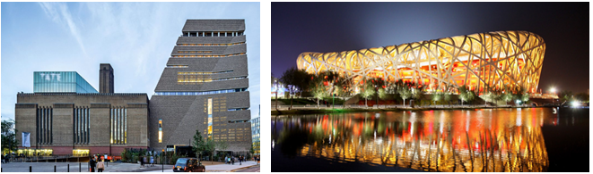
Figure 4: Tate Modern in London and the Bird's Nest stadium in Beijing; Source: (Carter, 2023; Rigby, 2011)
The adaptive reuse of CaixaForum also fits in with the global trend towards responsible building and environmental design. The success of this project in turning an old industrial building into a bustling culture hub shows how adaptive reuse can help prevent cities from growing too far apart and protect the environment. As a precedent, it may assist designers and urban planners advocating for the protection and adaptable reuse of existing buildings, which supports historical continuity and long-term growth.
Critical assessment:
The distinct ways in which "CaixaForum" is redeveloped illustrates how significant historical, societal, and cultural elements are for interior designing. When redeveloping historical places, these things become extremely essential. The case of CaixaForum reveals the underlying considerations based on which designing choices are based upon. The way in which CaixaForum project is taken up and accomplished serve as a prime example of how structural designs can incorporate historical elements with modern designs while also keeping their original characteristics alive. The notion of interior designing being a lot more than designing and erecting structures and that it should present a compelling narration is also emphasised in this study. It could be possible for architects and designers to acquire a lot about flexible reuse fundamentals and instruments from the "CaixaForum" case. Historical features of this building have been preserved whilst novel additions are introduced.
While contemplating the different ways the lessons learnt from the case of "CaixaForum" redevelopment project can be utilised today, it causes us anticipate how an interior designers' role continues to evolve in the contemporary age. Besides that, they need to be concerned about bigger problems like getting people involved with their surroundings, protecting cultures, advancing sustainability, and attempting to make sure things last a long time. CaixaForum serves as an ideal instance of how interior designing field is evolving continually. Because of such transformations, an effective strategy is needed that can take into account the concerned cultural, political, economic, and environmental factors.
By considering the work done by Herzog and De Meuron, primarily in the case of CaixaForum project, one may easily acquire an enriched understanding of how the world of architecture is shifting. It further stresses upon the significance of finding the right balance between the preservation of historical elements while also meeting the present development needs. Finally, the history of CaixaForum structure as a century old power station and now being redeveloped as a hustling cultural center, mirrors the significance of adaptive reuse concepts in coping up with emerging needs. Considering the emerging sustainability challenges and developmental needs of the present day world, adaptive reuse concept is likely to play a bigger role in coming years and help designers create new structural marvels for generations to come.

References:
201 Caixaforum Madrid (2022). Herzog & de Meuron. Available at: https://www.herzogdemeuron.com/projects/201-caixaforum-madrid/ (Accessed: 07 January 2024).
Aigwi, I.E., Duberia, A. and Nwadike, A.N., 2023. Adaptive reuse of existing buildings as a sustainable tool for climate change mitigation within the built environment. Sustainable Energy Technologies and Assessments, 56, p.102945.
Carter, L. (2023) Architects Herzog & de Meuron, the design duo behind Tate Modern and scores of other museums, are themselves the subject of a new exhibition, Artnet News. Available at: https://news.artnet.com/art-world/herzog-de-meuron-exhibition-2336005 (Accessed: 07 January 2024).
Gregorio Hurtado, S.D., Mohíno Sanz, M.I., Lorente Riverola, I., Lamíquiz Daudén, F.J. and Ardura Urquiaga, Á., 2019. Public space and mobility. The transformation of Madrid’s distrito centro.
Hatherley, O., 2018. Trans-Europe Express: Tours of a Lost Continent. Penguin UK.
Hreciuc, E., 2020. Ecological Footprint of The Electrical and Energy Industries as Cultural Challenge. Postmodern Openings, 11(4), pp.207-229.
Mao, D. (2018) Caixaforum Madrid, Medium. Available at: https://medium.com/@david.mao_33188/caixaforum-madrid-b92ac0cc5f04 (Accessed: 07 January 2024).
Milojković, A. and Nikolić, M., 2012. Museum architecture and conversion: From paradigm to institutionalization of anti-museum. Facta universitatis-series: Architecture and Civil Engineering, 10(1), pp.69-83.
Moshaver, A., 2011. Re architecture: Old and new in adaptive reuse of modern industrial heritage. Unpublished Master dissertation], Ryerson University.
Naqvi, S.M.S., 2023. Maximizing Green Space in a Building Complex through Alternative Landscape Design Elements (Doctoral dissertation, Guru Gobind Singh Indraprastha University).
Plevoets, B., 2021. Juxtaposing inside and outside: façadism as a strategy for building adaptation. The Journal of Architecture, 26(4), pp.541-558.
Rigby, J. (2011) Beijing Bird’s nest to white elephant?, Channel 4 News. Available at: https://www.channel4.com/news/beijing-birds-nest-to-white-elephant (Accessed: 07 January 2024).
Schröpfer, T., 2012. Ecological urban architecture: qualitative approaches to sustainability. Walter de Gruyter
Taddonio, S. and Aydeniz, E.N.K., 2020. Adaptive Reuse Proposals for The Former Electricity Factory in İzmir (Turkey). Contemporary Interventional Approaches for The ‘City Factory Project’. Uluslararası Peyzaj Mimarlığı Araştırmaları Dergisi (IJLAR) E-ISSN: 2602-4322, 4(1), pp.1-30.

